**11-4 Skills Practice**

***Areas of Regular Polygons and Composite Figures***

**Find the area of each regular polygon. Round to the nearest tenth.**

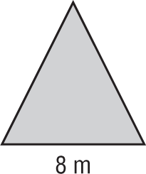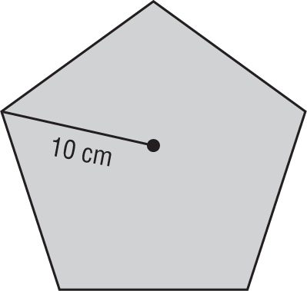 **1. 2.**

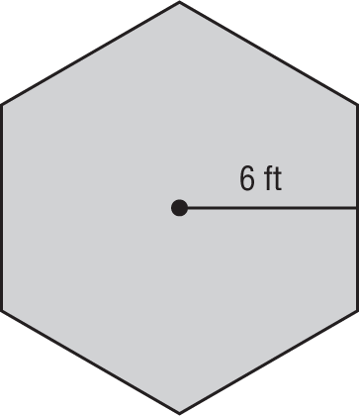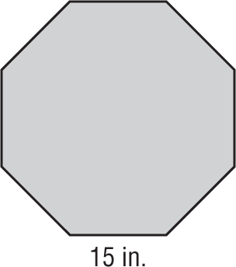 **3. 4.**

**Find the area of each figure. Round to the nearest tenth if necessary.**

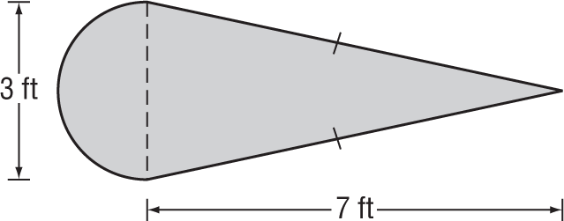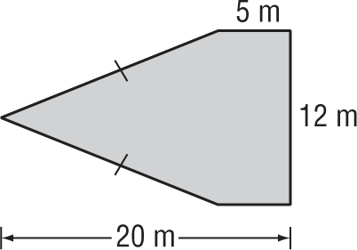 **5. 6.**

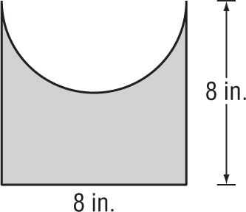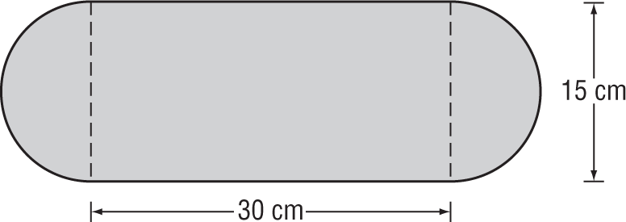 **7. 8.**