Name _______________________________ Unit 9 Test A
Graph the following functions (include two full periods). (4 points each)
1. y = 4sinx
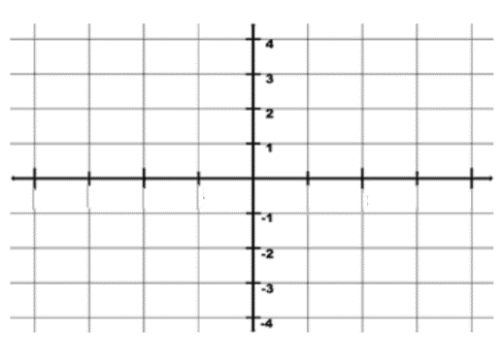

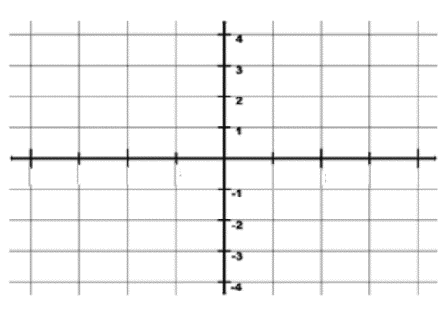
2. y = 2tan3x

3. y = sec(2x+π) – 1

4. y= -2cot(x-π/2)

5. y= 1-cos(3πx)

6. y= csc(x-π/4)

